Lab 6 Notes

In Exerc. 1 we created 5 datasets. Now we have 7 datasets. Note that now it is CosmosDB (NoSQL) instead of SQL API

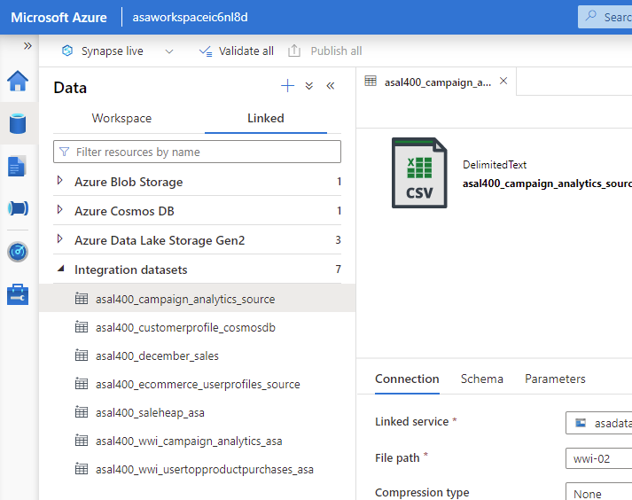

The code for Campaign Analytics Dataflow (Task 5) was saved as **asal400_lab2_writecampaignanalyticstoasa.json**

Exerc 2 – Task 1.12 🡺 I had to modify the script because I had a few integer types instead of string. I just replaced by the one provided

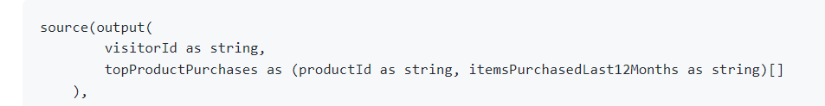

Task 1.19 🡺 userId, productid and preferredProducts are already integer, so no need to change.

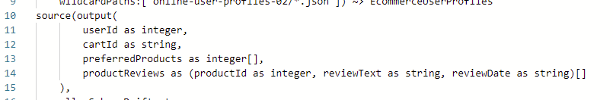

Task 1.21 🡺 Open the dropdown and select [] preferredProducts, then you typepreferredProductId in the **Name as**

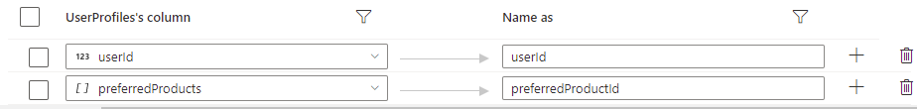

In Task 1.27 you will not preview data as you see in the screenshot

I saved the code for the data flow write_user_profile_to_asa.